How to label the particle trajectories

There are three classes of particles to label here. Those that have positive, negative and zero acoustic contrast.

Particles with **positive contrast** are generally pushed to the **middle** by the acoustic force.

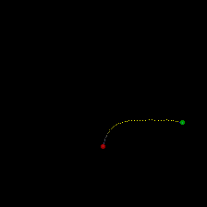 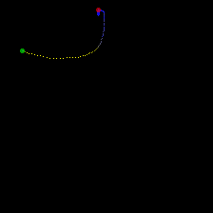

Figure 1: Positive contrast. The track starts at the green circle. Blue pixels indicate slow speeds. The color gradient then goes towards yellow that indicates higher speed. The track ends at the red circle.

Particles with **negative contrast** are generally pushed to the **sides** by the acoustic force.

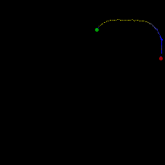 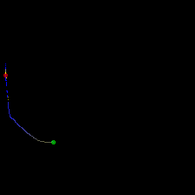

Figure 2: Negative contrast.

To complicate things we also need to take into consideration the acoustic streaming in the channel that also push the particles. See figure 4.

Particles with **zero contrast** are not generally pushed anywhere and only flow with the acoustic streaming.

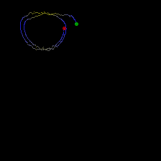 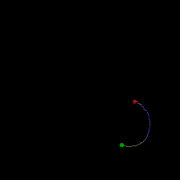

Figure 3: Zero contrast.

If you are unsure about a label you can press the “unsure”. However, try to do this as little as possible.

Sometimes the tracks look strange. Go for the most likely option in that case.

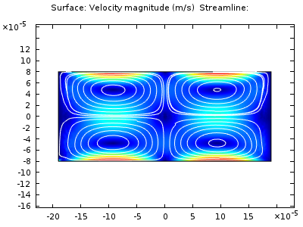

Figure 4: This is what the acoustic streaming lines should look like theoretically.

# Steps to take to start labeling things

1. Go to the folder where the program is in MATLAB
2. Type ‘labeler’ (or ‘labeler_TUTORIALVERSION’ if you are doing the tutorial) in the command window
   1. Tutorial version contains simulated images to train on. They are “easy”.
3. Press the drop down menu and select ‘New’ to create a new user.
   1. Input your name
   2. Now your name exists in the drop down menu
4. Select yourself in the drop down menu
   1. Always select yourself as the current annotator!!!
5. Now you see an image. Label the image by pressing the buttons.
   1. Labels are always saved behind the scenes continuously.
   2. The key binds are as follows
      * Go back = left arrow
      * Go forward = right arrow
      * Neg = n
      * Pos = p
      * Zero = z
      * Unsure = u